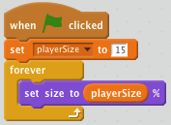**Player (Lesson 1)**

**Fish Food**

1)Upload the ocean background.

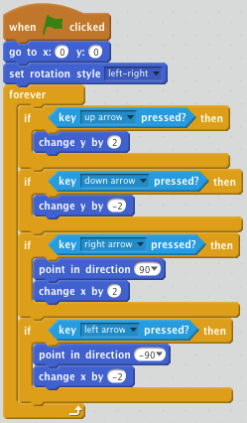2)Upload a fish sprite for the player.

3)Make a variable called playerSize and set it to 15.

4)Forever set the size to playerSize.

5)Drag over a new flag. Go to X:0 Y:0 and set the rotation style to left-right.

6)In a forever loop, make the fish move with the up and down arrows.

**Fish Movement (Lesson 2)**

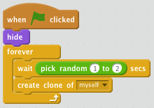

1)Upload a different fish sprite and add different fishes to that sprite.

2)When the flag is clicked you want to hide the costume and forever wait 1 – 2 seconds and create a clone of myself.

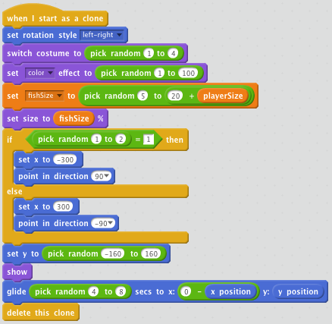3)When I start as clone, set rotation style left -right.

4)Switch costume and set color to random numbers.

5)Make a **fishSize** variable and set it to a random number. Add **playerSize** to the limit. Set size to fishSize.

6)Make it so there is a 50/50 chance it will spawn on the left or right side.

7)Set the y coordinate to a random number between (-160 to 160)

8)Show and glide to the other side of the screen.

9)Delete the clone.

****Scoring (Lesson 3)

1)Create a variable called **score.** Set to 0 at the start.

2)Create a variable called **fish eaten.** Set to 0 at the start.

3)change fishSize to for this sprite only.

4)replace all fishSize to size

5)switch **set to size** and **set size**

